**Installation instructions:**

Distributed Teleoperation in Virtual Environments

The current version works only for VisualStudio 2015 in Windows.

**1-Installation of Haptic Device**

- The drivers of the supported haptic devices can be found at ./HapticDeviceDrivers

- Supported devices: Falcon, Phantom Omni, Geomagic Touch, Force Dimension Omega series.

**2-Installation and compilation of Chai3d**

For distributed masterhahaand slave, there are two project solutions:

*/Master/Haptic.sln.sln*

*/Slave/Haptic.sln.sln*

- Click on both solutions to open them with MS Visual Studio

- The main project are under the folders

*/Master /HapticMaster*

*/Slave /HapticSlave*

- Build the solution (if CHAI3D is compiled for the first time, it may take some time)

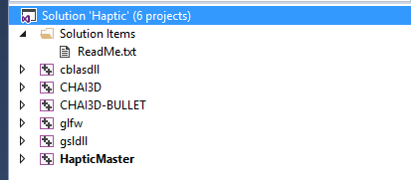

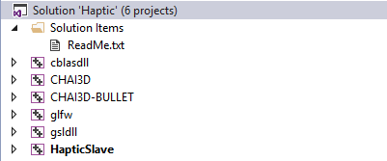

**3- Running demo application to test Haptic Communication library**

IMPORTANT NOTE: When you first run the haptic device, it needs calibration to display the force feedback. Otherwise, you may feel incorrect force feedback. Please follow the calibration instructions of the installed drivers

To successfully run the program, you need to connect one haptic devices (e.g. Falcon) to the master PC and one to the slave PC. When turning off the virtual environment settings (UseVirtualEnv=0 in the config file), you can control the slave device using the master device. When turning on the virtual environment, we do not really need the slave haptic device, the haptic device on the slave side is used for triggering an exact 1kHz haptic loop. Also note that the current version only provides the most limited functionality to make the virtual mode work correctly, for this reason the physical model of the virtual environment is significantly simplified. When switching from virtual mode to real mode or vice versa, you might need to adjust the settings of the virtual world accordingly in order to observe similar physical interactions.

- The location of the main projects (master and slave) are under

*/Master /HapticMaster*

*/Slave /HapticSlave*

- All necessary source files are located under the project folder

- The configuration file "config.cfg" is located under "/cfg" folder

- Before running the application adjust your desired deadband parameters in "config.cfg", and also input the master and slave IP. **Delay and position control are not supported in the current version.**

- In "config.cgf", there exists a flag called "RecordSignals" to save the signals of the teleoperation session into text files for further analysis. (not applicable)

The parameters in the config.cfg are:

RecordSignals = 0; // 0: Turn off recording, 1: Turn on recording (not applicable)

ForceDeadbandParameter = 0.1; // deadband parameter for force data reduction (slave side)

VelocityDeadbandParameter = 0.1; // deadband parameter for velocity data reduction (master side)

PositionDeadbandParameter = 0.0;// deadband parameter for position data reduction

ForceDelay = 0; // ms: constant network delay on Force feedback

CommandDelay = 0; // ms: constant network delay on Commanding channel

ControlMode = 1; // 0: position control, 1:velocity control

FlagVelocityKalmanFilter = 0; // 0: Kalman filter disabled 1: Kalman filter enabled on velocity signal

MasterIP = 127.0.0.1; // IP address of master. Localhost: 127.0.0.1

SlaveIP = 127.0.0.1; // IP address of slave. Localhost: 127.0.0.1

UseVirtualEnv //0:Turn off virtual environment; 1: Turn on virtual environment

Please running the program in Release mode:

- First run the slave application

- Then run the master application

- Wait until you see the environments. You can see both slave environment in the slave openGL window and the feedback video in the master openGL window.

Please follow the instruction screen of the application for the relevant keys as shown below:

******* Control mode keys *********************************

[k] - enable/disable Kalman filter on velocity: performs kalman filtering to reduce the noise on velocity

***********************************************************

******* Deadband increase/decrease keys ******************* (not applicable)

[q] - increase force deadband (+0.01)

[a] - decrease force deadband (-0.01)

[w] - increase velocity/position deadband (+0.01) : increases the deadband for corresponding control mode

[s] - decrease velocity/position deadband (-0.01) : decreases the deadband for corresponding control mode

***********************************************************

******* Virtual Environment Control keys ******************

[g] – enable/disable gravity (not applicable)

[f] – toggle full screen

[q] - Exit application

- Workspace adjustment

If you reach the limit of the physical workspace of the device, you press the button of the haptic devices (might be different from devices) and stop the movement of the virtual tool. Then, you can readjust your device handle and press the button again to restart controlling the virtual tool. With this you can reach all regions of the virtual workspace.